

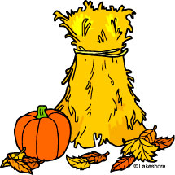
2B Weekly Fridge Sheet
Monday, October 19, 2015
Skills We’re Learning:
Spelling: ay and ai sounds

Reading: Summarizing using sequence of events

Story of the week:
A Trip to the Emergency Room
Homework: Read pages 222-225.

Grammar: Proper Nouns and Abbreviations

Math: Adding two digit numbers with and without regrouping

Social Studies: Where We Live
*Continue to study vocab and your address!
Vocabulary Words to Know:

serious- dangerous

broken- damaged or in pieces

personal- having to do with a person

informs- gives information to

heal- to become well or healthy again
Week 8 Spelling Words
(STUDY!!! Test Thurs.)

main wait sail

tail train jay

pay stay hay

may must spell

rain was about

Challenge Words
*follow
*paper
*near
This Week:
Monday: Homework goes home
-Vocabulary Sheet
-Booklet (pull off, fold, read, sign)
-Read Story: Tiny Seed
p. 222-225 (Listen, sign book card)
Thursday: Spelling & Reading Test
**HOMEWORK DUE**

Important Dates:
Wednesday - Picture Day
Bring an Apple or 2

Thursday - The Great Apple Crunch Day

Friday - No School
Teacher's Institute
Quarter Ends

Have a Great Week! ☺Mrs. Rinehart
Sign, Clip, and Return Bottom Slip for a token!

Student Signature:___________________ Parent Signature:_______________________
Expires 10/22/15

